**ONLINE DATA SUPPLEMENT**

**Title:** Veterans Affairs Patient Database (VAPD): Building nationwide granular data for clinical discovery

**Authors:** XiaoQing Wang, MPH, Brenda M. Vincent, MS, Wyndy Wiitala, PhD, Kaitlyn A. Luginbill, MPH, Elizabeth M. Viglianti, MD, MPH, Hallie C. Prescott, MD, MSc, Theodore J. Iwashyna, MD, PhD

**Table of Contents**

**Appendix A:** VAPD definitions for standardized nomenclature and data elements

**Appendix B:** Standard operation procedure for laboratory data extraction

**Appendix C:** Standard operation procedure for medications data extraction

**Appendix D:** Antibiotic drug classifications reference

**Appendix A: VAPD definitions for standardized nomenclature and data elements**

**VAPD Standardized Nomenclature**

|  |  |
| --- | --- |
| **Term** | **Conceptual definition** |
| VAPD | Veterans Affairs Patient Database (how we refer to the database throughout the paper) |
| Patient-facility-day | An individual day that a patient spent in the hospital, defined as calendar date. A patient-facility-day may be associated with multiple hospitalizations if a patient is transferred between hospitals |
| Patient | The term used to indicate the individual person (as opposed to participant, subject, Veteran, etc.) |
| Hospital | The physical place (site or facility) where the patient was treated |
| ICU | Intensive Care Unit |
| Laboratory | The physical lab (site) where the testing machines exist |
| Laboratory test | The concept of the test conducted by a laboratory (e.g. albumin, bilirubin). There may be various names and clinical synonyms for an individual lab test |
| Facility Laboratory test name | The name used to identify a lab test at a specific site (e.g. white blood cell count, WBC) |
| Test results | The result of a laboratory test |
| Laboratory test synonyms | Other clinical names for the same laboratory test (e.g. blood gas, carbon dioxide both map to the same lab test) |
| Facility laboratory code | Facility-specific code linked to lab test names (the variable name used in the Corporate Data Warehouse is LabChemTestSID) |
| Facility LOINC | Facility-specific code linked to LOINC codes (the variable name used in the Corporate Data Warehouse is LOINCSID) |
| Bedded stay | Any stay in a healthcare facility where a patient is provided a bed, including hospital, nursing facility, mental health facility, or domiciliary for homeless Veterans |
| Specialty stay | A portion of a bedded stay defined by the treating specialty. Each bedded stay is composed of one or more specialty stays |
| Acute specialty stay | A specialty stay that is for an acute medical condition |
| Non-acute specialty stay | A specialty stay that is not for an acute medical condition |
| Hospitalization | One or more consecutive acute specialty stays |
| Specialty transfer | Occurs when a patient’s care is transitioned from one treating specialty to another treating specialty |
| Topography | A specific description of an anatomic region of the body where lab specimen was drawn (e.g. arterial blood, plasma, blood, serum) |

**Data Elements**

|  |  |  |
| --- | --- | --- |
| **Clinical Data Type** | **Concepts** | **Variable Level** |
| Demographics | Age, race, sex | Patient |
| Laboratory tests | Daily high/low values for tests ordered:  Albumin, bilirubin, creatinine, platelets, potassium, white blood cell count, urea, bicarbonate, sodium, lactate, glucose, hematocrit, hemoglobin, arterial blood gas for mechanical ventilation, pH, PaCO2, & PaO2 | Patient-facility-day |
| Vital signs | respiratory rate, mean arterial blood pressure, heart rate, systolic blood pressure, diastolic blood pressure, core temperature | Patient-facility-day |
| Hospital admission | Admission and discharge dates, length of stay | Hospitalization |
| Severity scores | 31 Elixhauser comorbidities, Inpatient Evaluation Center (IPEC) severity score | Hospitalization |
| ICU admission | ICU indicator, ICU length of stay, ICU admission and discharge dates | Hospitalization, patient-facility-day |
| Discharge disposition | Discharge to home, transfer to another acute care, death | Hospitalization |
| Death status | Death date as of the end of the calendar year and an indicator for death in the hospital | Patient, hospitalization |
| Hospital characteristics | State, region, number of operating beds, number of beds, indicator for teaching hospital, facility level, | Hospital |
| Diagnoses | ICD-9 for primary diagnosis and up to 14 additional diagnoses, the single-level Clinical Classification Software category for primary diagnosis | Hospitalization |
| Sepsis definitions | Angus definition of infection, Angus definition of acute organ dysfunction, Angus definition of explicit diagnosis, Angus definition of Sepsis, Dombrovskiy definition of infection, Dombrovskiy definition of acute organ dysfunction, Dombrovskiy definition of explicit diagnosis, Dombrovskiy definition of Sepsis, CDC definition | Hospitalization |
| Antibiotics | Antibiotic name and route (i.e., Penicillin_IV, Amoxicillin_PO) were grouped into multiple antibiotic classes which includes Penicillin, 1st – 4th Generation Cephalosporin, Fluoroquinolone, Antiviral, Antifungal, etc. A complete list and classification of Antibiotics is provided in Appendix D. | Patient-facility-day |
| Microbiology | Blood culture, other micro labs (e.g., urine, sputum) | Patient-facility-day |
| Vasoactive drugs | Norepinephrine, epinephrine, phenylephrine, dopamine, vasopressin | Patient-facility-day |
| Sedative drugs | Propofol, Ketamine, Midazolam, Lorazepam | Patient-facility-day |
| Paralytic drugs | Cisatracurium, Vecuronium, Etomidate | Patient-facility-day |
| Analgesic drugs | Fentanyl, Morphine, Hydromorphone (Dilaudid) | Patient-facility-day |
| Other drugs | Lactulose, Rifaximin | Patient-facility-day |
| Prior hospitalization history | Number of hospitalizations for the patient in the prior calendar year | Hospitalization |
| Readmissions | Date of readmitting hospitalizations in 30 and/or 90 days, diagnosis type of readmitting hospitalizations | Hospitalization |

**Appendix B: Standard operating procedure for laboratory data extraction**

**Goal:** Identify labs drawn for a patient during an inpatient stay on day-by-day basis. This SOP provides step by step instructions on how to extract pharmacy data from Corporate Data Warehouse (CDW). Medications of interest are extracted annually by calendar year.

**Data Organization:**

* CDW: Data stored in the Corporate Data Warehouse are organized as relational tables. Data are separated into multiple domains (such as vital signs, laboratory, inpatient, outpatient, etc.) and tables within each domain. Linking keys (ending in ‘SID’) are used to reassemble data elements of interest to create tables for analysis.
* Dimension (Dim) tables: supporting tables which hold meta data. For example, the Inpatient diagnosis tables would contain a key for a diagnosis code and the diagnosis dim table would provide the actual diagnosis code value.
* LabChem Domain: domain containing laboratory tests and results.
* Field: a column of data in a table.
* PatientICN: unique patient ID. Each facility has an ID for a patient (PatientSID) so that a patient seen at multiple facilities would have multiple PatientSIDs but the PatientICN is unique at the patient-level.

**LOINC Codes**

**Regenstrief LOINC Database:** <https://loinc.org/>

* A universal code system for tests, measurements, and observations
* Format: a formal, distinct, and unique 6-part name given to each term for tests.
* The analyst must create an account first before searching the database: <https://search.loinc.org/searchLOINC/>
* Example: searching “White Blood Cell” will yield LOINC codes: 66768-3, 12227-5, 61182-2, etc.

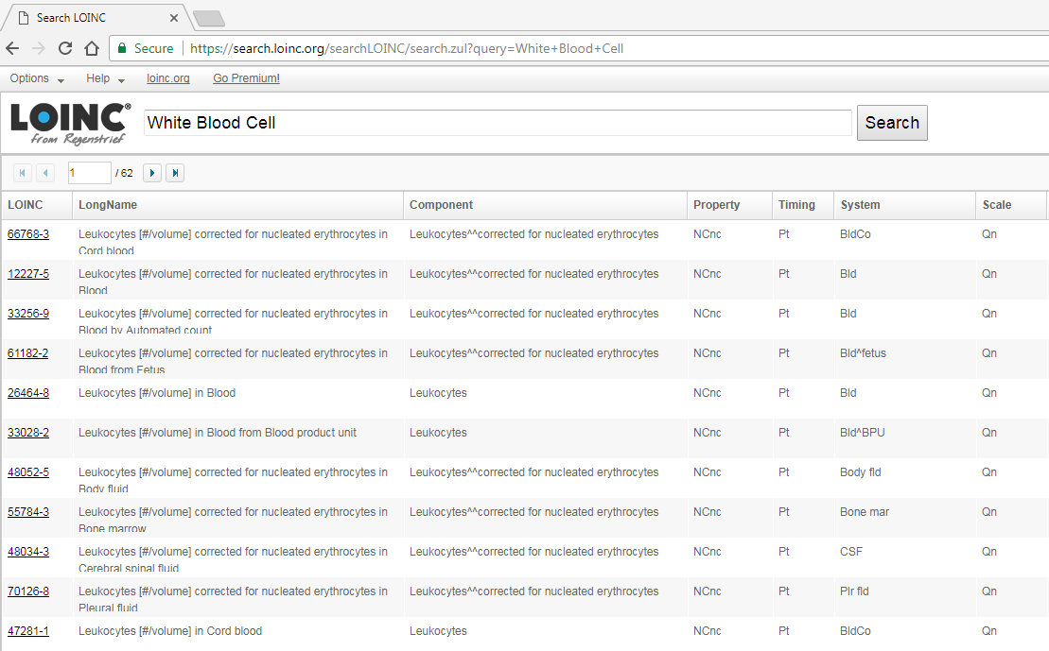

**CDW LOINC & LabChemTest Tables**

There are two CDW tables to look up potential labs, to capture as many lab observations as possible:

1. Dim.LOINC: LOINC & LOINCSID
   * Each LOINC can have multiple LOINCSIDs, because each Sta3n (Facility_ID) has a unique LOINCSID for a LOINC code.
   * Find all LOINCSIDs associated with the given LOINC code.
2. Dim.LabChemTest: LabChemTestName and LabChemTestSID
   * Each LabChemTestName can have multiple LabChemTestSIDs depending on Sta3n.
   * Find all LabChemTestSIDs associated with the given lab name.

Dim.LOINC Dim.LabChemTest

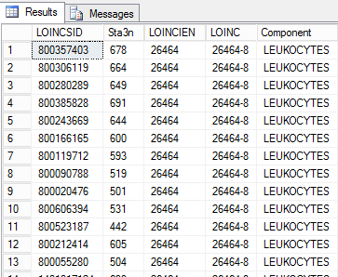 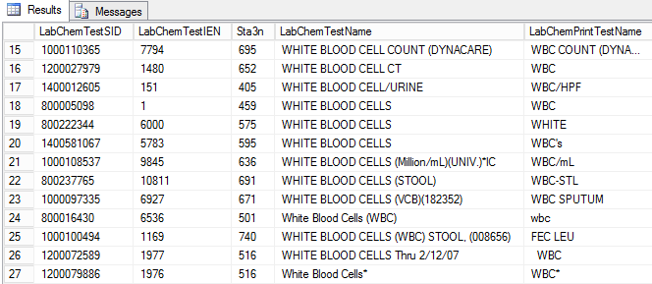

**Defining & Extracting New Labs**

**Step 1: Search Regenstrief Institute Website to Identify LOINC Codes**

* Get a list of synonyms and names for a given lab from Principle Investigator (PI) who has clinical knowledge
  + Example: Arterial Blood Gas or Venous Blood Gas Labs:
    - PaCO2, PaO2, PCO2, PO2, blood gas, oxygen, partial pressure, carbon dioxide
* Search the synonyms and names on the LOINC database, then copy and paste the results to Excel (one lab synonym/name per sheet by their search keyword).
  + Data cleaning: When using multiple prompts, be sure to de-duplicate across sheets to reduce hand-arbitration burden.
* Identify a list of synonyms and names for a given lab from PIs to exclude that are clearly not capturing the lab test of interest:
  + Example: exclude any LOINC component that contains “cord blood”, “mixed venous”, “capillary”, “airway circuit”
* Send to at least two PIs to individually review which LOINC codes to keep and exclude.
* Analyst makes a list of LOINC codes where PIs disagree, send to PIs again for consensus.

**Step 2: Identifying Facility Lab Codes (LOINCSIDs) & Lab Test Names (LabChemTestSIDs)**

**LOINCSIDs**

* Analyst creates a csv file with all the verified LOINC codes for the specific lab from Step 1.
  + Include the date in the file name and add the “as of date” column for record keeping purposes

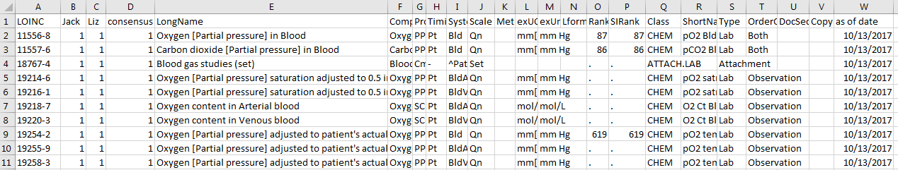

* + Additionally, create a list of LOINC codes that were excluded by PIs. In future years, exclude those LOINC codes from the list provided to PIs to shorten the review process.
* Pull these verified LOINC codes from CDW table: dim.loinc 🡪 get all the corresponding LOINCSIDs to be used later.
* Export a list of LOINCSIDs in csv format and add the date it was created for record keeping.

Example SAS code:

**PROC** **SQL**;

create table ABG_loincsid as

select LOINC, Component, Sta3n, LOINCSID

from [CDWWork]**.**[Dim]**.**[loinc]

where loinc in ('11556-8', '11557-6', '18767-4', '19214-6','19216-1', '19218-7','19220-3');

QUIT;

**LabChemTestSIDs**

* Look at Dim.LabChemTest table to identify all distinct LabChemTestNames associated with the lab of interest.
  + Using LOINC lab component keywords identified in Step 1 and 2, review and select all possible LabChemTestNames associated with those LOINCs
  + Review LabChemTestNames to come up with a few key strings to use to identify additional test names.
  + Ask PIs to review the list of LabChemTestNames to pull
* Pull those LabChemTestNames from Dim.LabChemTest table and then give to at least two PIs to review and decide which LabChemTestNames to keep or exclude.
* Analyst makes a list of LabChemTestNames where PIs disagree, send to PIs again for consensus.
* Analyst then creates an excel file of all the LabChemTestNames associated with given lab, exactly as they appear in the CDW Dim.LabChemTest table.
  + Make sure to first change LabChemTestNames such as '%NEUTROPHILS (CZ)(Dc’d)' to '%NEUTROPHILS (CZ)(Dc"d)' in the excel file first before saving it as csv file

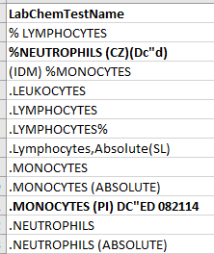

* + Additionally, create a list of LabChemTestNames that were excluded by PIs. In future years, exclude those LabChemTestNames from the list provided to PIs to shorten the review process.
* Pull these LabChemTestNames from CDW table: Dim.LabChemTest 🡪 get all the corresponding LabChemTestSIDs to be used later.

Example SAS code:

**PROC** **SQL**;

CREATE TABLE ABG_labchemsid (COMPRESS=YES) AS

SELECT Labchemtestsid, LabChemTestName, LabChemPrintTestName, Sta3n

FROM [CDWWork]**.**[Dim]**.**[LabChemTest]

WHERE labchemtestname in ('*VBG(VENOUS BLOOD GAS)', '0ABG RESULT', '0VENT (ABG)', 'ABG');

QUIT;

**Step 3: Extract Verified LOINCSIDs & LabChemTestSIDs**

* Extract verified LOINCSIDs and LabChemTestSIDs from CDW, exclude those with missing result values.
* Remove duplicate labs.
* Get PatientICN & reformat LabChemSpecimenDateTime to MM/DD/YYYY.

Example SAS code:

/*pull ABG loincsids and labchemtestsids from CDW for 2014-2017*/

**PROC** **SQL** ;

CREATE TABLE abg_2014_2017 (compress = yes) AS

SELECT a.Sta3n, a.LabChemTestSID, a.PatientSID, a.LabChemSpecimenDateTime, a.LabChemResultNumericValue, a.TopographySID, a.LOINCSID, a.Units, a.RefHigh, a.RefLow, d.Topography

FROM [INSERT STUDY NAME]**.**[src]**.**[Chem_PatientLabChem] AS A

INNER JOIN ABG_loincsid b on a.Loincsid=b.Loincsid

LEFT JOIN [CDWWork]**.**[Dim]**.**[topography] AS d ON A.TopographySID =D.TopographySID

WHERE a.LabChemSpecimenDateTime >= &startdate. and a.LabChemSpecimenDateTime < &enddate.

UNION

SELECT a.LabChemSID, a.LabSubjectSID, a.Sta3n, a.LabPanelIEN, a.LabPanelSID, a.LongAccessionNumberUID, a.ShortAccessionNumber,

a.LabChemTestSID, a.PatientSID, a.LabChemSpecimenDateTime, a.LabChemSpecimenDateSID, a.LabChemCompleteDateTime, a.LabChemCompleteDateSID,

a.LabChemResultValue, a.LabChemResultNumericValue, a.TopographySID, a.LOINCSID, a.Units, a.RefHigh, a.RefLow, d.Topography

FROM [INSERT STUDY NAME]**.**[src]**.**[Chem_PatientLabChem] a

INNER JOIN ABG_labchemsid b ON a.labchemtestsid=b.labchemtestsid

LEFT JOIN [CDWWork]**.**[Dim]**.**[topography] AS d ON A.TopographySID =D.TopographySID

WHERE loincsid=-**1** and

a.LabChemSpecimenDateTime >= &startdate. and a.LabChemSpecimenDateTime < &enddate.

**QUIT**;

/*remove duplicate labs */

**PROC** **SORT** DATA=abg_2014_2017 nodupkey out=abg_mechvent_2014_2017;

BY patientSID sta3n LabChemResultNumericValue LabChemSpecimenDateTime;

**RUN**;

/*get unique patienticn*/

**proc** **sql**;

create table abg_mechvent_2014_2017_V2 (compress=yes) as

select a.*, b.patienticn

from abg_mechvent_2014_2017 a

left join [INSERT STUDY NAME]**.**[src]**.**[CohortCrosswalk] b on a.PatientSID=b.PatientSID ;

QUIT;

/*change patienticn into numeric*/

**DATA** abg_mechvent_2014_2017_V3 (rename=patienticn2=patienticn compress=yes);

SET abg_mechvent_2014_2017_V2;

patienticn2 = input(patienticn, **10.**);

drop patienticn;

LabSpecimenDate=datepart(LabChemSpecimenDateTime); /*convert datetime to date*/

format LabSpecimenDate mmddyy10.;

**RUN**;

**Step 4: Look at Frequencies and Descriptive of All Labs**

* Examine all lab names, units, topography, and lab result values.
  + Standardize the unit formats (create clean_unit variable) and exclude incorrect ones
    - Make units all capital letter, delete ‘.’ (periods), compress any spaces
    - PI decide to exclude those with unclear or wrong units
  + Look at topography and exclude incorrect ones
    - Note that we have compared DefaultTopography and CollectionSample from Dim.CollectionSample table and found that Topography from Dim.Topography has the most complete non-missing information
    - PIs decide which to keep or exclude
  + Keep only those with frequencies > 100
  + Separate dataset into to those with units vs. those without units:
    - Aggregate by LabChemTestName, Topography, and clean_unit:
      * Clean up LabChemTestNames. Example:

%let LYMPHOCYTE_AUTO =('LYMPH (AUTO)','LYMPH (AUTO)','LYMPHS (AUTO)', 'LYMPHOCYTE (AUTO)');

%let LYMPHOCYTE_MANUAL=('LYMPHS (MANUAL)','LYMPHS (MAN)','LYMPHSMANUAL','LYMPHOCYTE MANUAL');

* + - * Investigate normal ranges for lab values: RefHigh and RefLow. Some LabChemTestSIDs have multiple RefHigh and RefLow values. Keep them separate, do not aggregate or deduplicate.
      * Calculate the median, 10th percentile, 90th percentile, RefHigh and RefLow for each aggregated LabChemTestName, Topography, and clean_unit
      * Sort by LabChemTestName, clean_unit, RefLow, RefHigh
      * Send to two PIs to individually review
      * Analyst creates list where PIs disagree, then send to PIs again to sort out. PIs are trying to ascertain if the specific lab seems plausible for the lab of interest. They flag those that seem “weird’

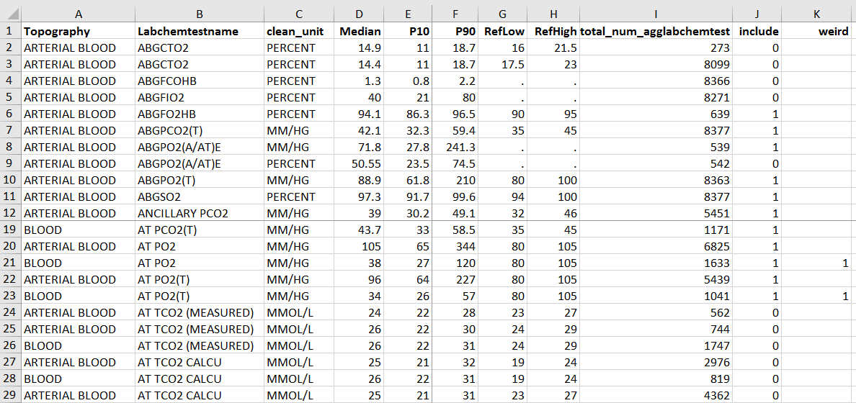

* + - Make Histograms on those weird/unclear ones so that the PIs can re-evaluate if they seem plausible for the lab of interest.

Example SAS code:

/*clean up and standardize units*/

**DATA** pco_2014_C2;

SET abg_mechvent_2014_2017_V3 ;

Units2=upcase(units); /*turn all units into uppercase*/

units3=compress(Units2,'.'); /*removes '.' in units*/

clean_unit=compress(units3); /*removes all blanks (by default - specify options to remove other chars)*/

drop units2 units3;

**RUN**;

/*Look at Unit and Topography frequencies and PIs help decide which to exclude or keep*/

/*clean/drop units & topography*/

**DATA** pco_2014_C3;

SET pco_2014_C2;

if clean_unit in ('FAHRENHEIT','L/MIN','LPM','CC/100ML','C','OBS','%CAL','326','DEGREESC','G/DL','MG/DL') OR

topography in ('MIXED VENOUS','URINE','MIXED VENOUS BLOOD','VENOUS BLOOD (MIXED)','PLEURAL FLUID','MIXED VEN/ART BLD','SWAN-GANZ CATHETER','BILE','FECES','PERITONEAL FLUID')

then delete;

if clean_unit='VOL%' or clean_unit='%' or clean_unit='%MEASURED' then clean_unit='PERCENT';

if topography='SERUM-UNK' or topography='serum' then topography='SERUM';

**RUN**;

/*Example codes to look at descriptive of lab values with or without units*/

/*get IQR on non-missing units dataset*/

**PROC** **MEANS** DATA=non_missing_unit_C4;

VAR LabChemResultNumericValue;

by Agg_count;

output out=non_missing_unit2(drop=_freq_) min= mean= median= std= max= p10= p90=/ autoname;

**RUN**;

/*left join descriptives back to original dataset*/

**PROC** **SQL**;

CREATE TABLE non_missing_unit3 AS

SELECT A.*, b.LabChemResultNumericVal_Median as Median, b.LabChemResultNumericValue_P10 as P10, b.LabChemResultNumericValue_P90 as P90

FROM non_missing_unit_C3 A

LEFT JOIN non_missing_unit2 B ON A.Agg_count=B.Agg_count;

**QUIT**;

/*make a list of those uncertain LabChemTestSIDs, and then only create histograms for those uncertain ones*/

**PROC** **SORT** DATA=test;

BY Labchemtestname median;

**RUN**;

**proc** **sgplot** data=test noautolegend;

histogram LabChemResultNumericValue;

by Labchemtestname median;

**run**;

**Step 5: Perform Spot Checks**

* Match verified labs to the cohort of interest.
* Randomly select ~50 patient days on which a given lab was drawn and ~10 on which the lab was not drawn (in order to ensure that missing labs in CDW were not collected that day). Have another person on the team (blindly) identify the lab values from that day from CPRS/VistA (or indicate that that lab was not drawn that day), and compare to the extracted CDW values. A clinician can have a second look if anything is weird or questionable.

**Appendix C: Standard operating procedure for medications data extraction**

**Goal:** Identify medications administered during an inpatient stay on day-by-day basis. This SOP provides step by step instructions on how to extract pharmacy data from Corporate Data Warehouse (CDW). Medications of interest are extracted annually by calendar year.

**Data Organization:**

* CDW: Data stored in the Corporate Data Warehouse are organized as relational tables. Data are separated into multiple domains (such as vital signs, laboratory, inpatient, outpatient, etc) and tables within each domain. Linking keys (ending in ‘SID’) are used to reassemble data elements of interest to create tables for analysis.
* Dimension (Dim) tables: supporting tables which hold meta data. For example, the Inpatient diagnosis tables would contain a key for a diagnosis code and the diagnosis dim table would provide the actual diagnosis code value.
* Pharmacy Bar Code Medication Administration (BCMA) Domain: describes the medication administration process in the inpatient setting. Several types of information are available including the dates and time the medication was ordered, delivered and administered to the patient. Details of the medication (name, form, dose, routes of administration, additives and ingredients) are stored in this domain as well.
* PatientICN: unique patient ID. Each facility has an ID for a patient (PatientSID) so that a patient seen at multiple facilities would have multiple PatientSIDs but the PatientICN is unique at the patient-level.

**Step 1: List of Target Medications**

* Principle Investigators generate a list of target medications

**Step 2: Search and Identify All LocalDrugSIDs Associated with Medications of Interest**

* Character search medications of interest from all fields containing drug names. For example, using LIKE operator can search for specific pattern or words in a column.
  + WHERE a.LocalDrugNameWithDose like '%PROPOFOL%' finds any values in LocalDrugNameWithDose field that have 'PROPOFOL' in any position.
* Extract the LocalDrugSIDs for all the matching medications from the Dim tables.
* There are three Dim tables containing inpatient medication administration:

1. Dim.LocalDrug:

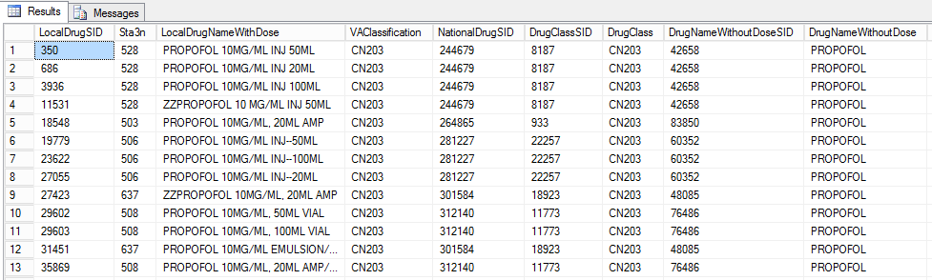

/*step 1: get all the LocalDrugSIDs associated with list of drugs*/

/*first pull all LocalDrugSIDs*/

**PROC** **SQL**;

CREATE TABLE localdrugsid AS

SELECT a.DrugNameWithoutDose, a.LocalDrugNameWithDose, a.NationalDrugNameWithDose,a.NationalDrug, a.Sta3n, a.LocalDrugSID

FROM Dim**.**LocalDrug AS A

WHERE a.LocalDrugNameWithDose like '%PROPOFOL%' OR a.DrugNameWithoutDose like '%PROPOFOL%'

OR a.NationalDrug like '%PROPOFOL%' OR a.NationalDrugNameWithDose like '%PROPOFOL%';

**QUIT**;

1. Dim.IVSolutionIngredient:

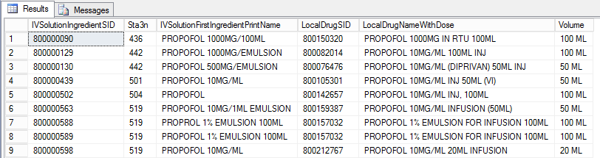

/*[Dim].[IVSolutionIngredient]*/

**PROC** **SQL**;

CREATE TABLE IVSolutionIngredient AS

SELECT a.IVSolutionIngredientSID, a.LocalDrugNameWithDose, a.Sta3n, a.LocalDrugSID, a.Volume, a.IVSolutionFirstIngredientPrintName

FROM Dim**.**IVSolutionIngredient AS A

WHERE a.LocalDrugNameWithDose like '%PROPOFOL%' or a.IVSolutionFirstIngredientPrintName like '%PROPOFOL%';

**QUIT**;

1. Dim.IVAdditiveIngredient:

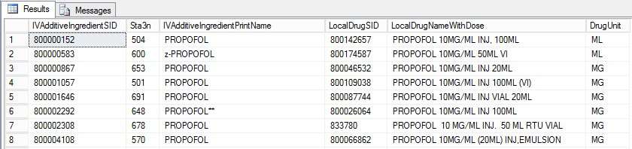

/*[Dim].[IVAdditiveIngredient]*/

**PROC** **SQL**;

CREATE TABLE IVAdditiveIngredient AS

SELECT a.IVAdditiveIngredientSID, a.LocalDrugNameWithDose, a.Sta3n, a.LocalDrugSID, a.DrugUnit, a.IVAdditiveIngredientPrintName

FROM Dim**.**IVAdditiveIngredient AS A

WHERE a.LocalDrugNameWithDose like '%PROPOFOL%' or a.IVAdditiveIngredientPrintName like '%PROPOFOL%';

**QUIT**;

**Step 3: Remove Duplicate LocalDrugSIDs, Screen Exclusions, & Create Drug_name Field**

* Combine all data extractions from the three Dim tables, remove duplicate LocalDrugSIDs.
* Screen drug names to exclude any medications with word “research” and/or “study”.
* Label each LocalDrugSID as a medication indicator fields.

/*label LocalDrugSIDs with drug_name field*/

**PROC** **SQL**;

CREATE TABLE pharm3 AS

SELECT *,

case when LocalDrugNameWithDose like '%PROPOFOL%' or LocalDrugNameWithDose like 'PROPOFOL%' or LocalDrugNameWithDose like 'ZZ DIPRIVAN%' or LocalDrugNameWithDose like 'DIPRIVAN%' then 'PROPOFOL'

END AS drug_name

FROM all_undup_localdrugsids_table

**QUIT**;

**Step 4: Extract Medication Administrations Data from Inpatient BCMA Tables**

* To identify date and time for each medication administration to specific patients.

For each BCMA Table:

Src.BCMA_BCMADispensedDrug:

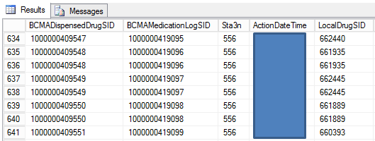

* Only select the LocalDrugSIDs in step 3.

/*step 2: pull BCMA_pharm tables*/

/*get 2014 BCMA_BCMADispensedDrug*/

**PROC** **SQL**;

create table BCMADispensedDrug as

SELECT a.*

FROM Src**.**BCMA_BCMADispensedDrug as A

where a.ActionDateTime >= '2014-01-01' and a.ActionDateTime <='2014-12-31'

and A.LocalDrugSID IN (SELECT LocalDrugSID FROM pharm3);

/*only select those localdrugsids in step 3*/

**quit**;

/*get drug_name field that was created*/

**PROC** **SQL**;

CREATE TABLE BCMADispensedDrug_3 AS

SELECT A.*, B.drug_name

FROM BCMADispensedDrug A

LEFT JOIN pharm3 B

ON A.LocalDrugSID=B.LocalDrugSID;

**QUIT**;

Src.BCMA_BCMASolution:

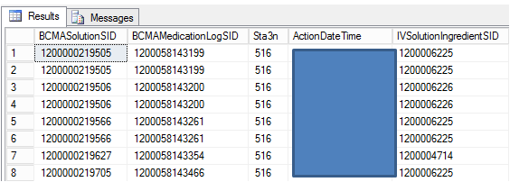

* Only select the IVSolutionIngredientSIDs in step 2B.
* Link IVSolutionIngredientsSIDs with LocalDrugSIDs to get drug_name field.

/*get BBCMA_BCMASolution*/

**PROC** **SQL**;

create table temp.BCMA_Solution as

SELECT a.*

FROM Src**.**BCMA_BCMASolution as A

where a.ActionDateTime >= '2014-01-01' and a.ActionDateTime <='2014-12-31' and IVSolutionIngredientSID IN (SELECT IVSolutionIngredientSID FROM IVSolutionIngredient);

**QUIT**;

**PROC** **SQL**; /*get LocalDrugSID*/

CREATE TABLE BCMA_Solution3 AS

SELECT A.*, b.LocalDrugSID

FROM BCMA_Solution A

LEFT JOIN IVSolutionIngredient B

ON A.IVSolutionIngredientSID=B.IVSolutionIngredientSID;

**QUIT**;

**PROC** **SQL**; /*get drug_name*/

CREATE TABLE BCMA_Solution4 AS

SELECT A.*, b.drug_name

FROM BCMA_Solution3 A

LEFT JOIN pharm3 B

ON A.LocalDrugSID=B.LocalDrugSID;

**QUIT**;

Src.BCMA_BCMAAdditive:

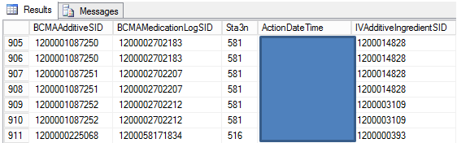

* Only select the IVAdditiveIngredientsSIDs in step 2C.
* Link IVAdditiveIngredientsSIDs with LocalDrugSIDs to get drug_name field.

/*get BBCMA_BCMAAdditive*/

**PROC** **SQL**;

create table temp.BCMA_BCMAAdditive as

SELECT a.*

FROM Src**.**BCMA_BCMAAdditive as A

where a.ActionDateTime >= '2014-01-01' and a.ActionDateTime <='2014-12-31' and IVAdditiveIngredientSID IN (SELECT IVAdditiveIngredientSID FROM IVAdditiveIngredient);

**QUIT**;

**PROC** **SQL**; /*get LocalDrugSID*/

CREATE TABLE BCMA_BCMAAdditive3 AS

SELECT A.*, b.LocalDrugSID

FROM BCMA_BCMAAdditive A

LEFT JOIN IVAdditiveIngredient B

ON A.IVAdditiveIngredientSID=B.IVAdditiveIngredientSID;

**QUIT**;

**PROC** **SQL**; /*get drug_name*/

CREATE TABLE BCMA_BCMAAdditive4 AS

SELECT A.*, b.drug_name

FROM BCMA_BCMAAdditive3 A

LEFT JOIN pharm3 B

ON A.LocalDrugSID=B.LocalDrugSID;

**QUIT**;

* Create action_date from ActionDateTime for each. EX: ActionDate=datepart(ActionDateTime);
* Get unique patient ID: patienticn.
* Combine the three datasets: BCMA_BCMAAdditive4, BCMA_Solution4, and BCMADispensedDrug_3.

**Step 5: Remove Duplicates and Reformat Dataset**

* Remove duplicates by unique patient, drug_name, and action_date.
* Transpose data so that each row is a patient-facility-day.

/*transpose dataset if needed*/

**DATA** trans_all_otherdrugs (compress=yes);

SET final.other_drugs;

keep patienticn ActionDate drug_name;

**RUN**;

**PROC** **TRANSPOSE** DATA=trans_all_otherdrugs OUT=final.trans_all_otherdrugs (DROP=_NAME_) PREFIX=drugname_;

BY patienticn ActionDate;

VAR drug_name;

**RUN**;

**Step 6: Spot Checks**

* Randomly select ~50 patient-days of drug delivery and ~10 patient-days of non-delivery to validate in CPRS/VistA. A clinician can have a second look if there are discrepancies.

**Appendix D: Antibiotic drug classifications reference**

|  |  |  |
| --- | --- | --- |
| Antibiotic_Route | Variable Name | Label (Abx Class) |
| Penicillin_IV | abx1 | penicillin |
| Amoxicillin_PO | abx1 | penicillin |
| Amoxicillin/Clavulanate_PO | abx1 | penicillin |
| Amoxicillin/Clavulanate_IV | abx1 | penicillin |
| Ticarcillin/Clavulanate_IV | abx1 | penicillin |
| Ampicillin/Sulbactam_IV | abx1 | penicillin |
| Ampicillin_IV | abx1 | penicillin |
| Ampicillin_PO | abx1 | penicillin |
| Nafcillin_IV | abx1 | penicillin |
| Piperacillin_IV | abx1 | penicillin |
| Penicillin_PO | abx1 | penicillin |
| Dicloxacillin_IV | abx1 | penicillin |
| Dicloxacillin_PO | abx1 | penicillin |
| Oxacillin_IV | abx1 | penicillin |
|  |  |  |
| Piperacillin/Tazobactam_IV | abx2 | anti_pseudomonal_pcn |
|  |  |  |
| Cefazolin_IV | abx3 | 1st_gen_cephalosporin |
| Cephalexin_PO | abx3 | 1st_gen_cephalosporin |
| Cefadroxil_PO | abx3 | 1st_gen_cephalosporin |
| Cefoxitin_IV | abx4 | 2nd_gen_cephalosporin |
| Cefuroxime_IV | abx4 | 2nd_gen_cephalosporin |
| Cefuroxime_PO | abx4 | 2nd_gen_cephalosporin |
| Cefaclor_PO | abx4 | 2nd_gen_cephalosporin |
| Cefprozil_PO | abx4 | 2nd_gen_cephalosporin |
| Cefotetan_IV | abx4 | 2nd_gen_cephalosporin |
| Cefixime_PO | abx5 | 3rd_gen_cephalosporin |
| Ceftibuten_PO | abx5 | 3rd_gen_cephalosporin |
| Ceftriaxone_IV | abx5 | 3rd_gen_cephalosporin |
| Ceftazidime_IV | abx5 | 3rd_gen_cephalosporin |
| Cefdinir_PO | abx5 | 3rd_gen_cephalosporin |
| Cefotaxime_IV | abx5 | 3rd_gen_cephalosporin |
| Ceftazidime/Avibactam_IV | abx5 | 3rd_gen_cephalosporin |
| Cefpodoxime_PO | abx5 | 3rd_gen_cephalosporin |
| Cefepime_IV | abx6 | 4th_gen_cephalosporin |
|  |  |  |
| Ofloxacin_PO | abx7 | fluoroquinolone |
| Ofloxacin_IV | abx7 | fluoroquinolone |
| Ciprofloxacin_IV | abx7 | fluoroquinolone |
| Ciprofloxacin_PO | abx7 | fluoroquinolone |
| Levofloxacin_IV | abx7 | fluoroquinolone |
| Levofloxacin_PO | abx7 | fluoroquinolone |
| Moxifloxacin_PO | abx7 | fluoroquinolone |
| Moxifloxacin_IV | abx7 | fluoroquinolone |
| Norfloxacin_PO | abx7 | fluoroquinolone |
|  |  |  |
|  |  |  |
| Telavancin_IV | abx8 | Vancomycin_IV |
| Dalbavancin_IV | abx8 | Vancomycin_IV |
| Oritavancin_IV | abx8 | Vancomycin_IV |
| Vancomycin_IV | abx8 | Vancomycin_IV |
|  |  |  |
| Vancomycin_PO | abx9 | Vancomycin_PO |
| Fidaxomicin_PO | abx9 | Vancomycin_PO |
| Fidaxomicin_IV | abx9 | Vancomycin_PO |
|  |  |  |
| Acyclovir_IV | abx10 | antiviral |
| Acyclovir_PO | abx10 | antiviral |
| Peramivir_IV | abx10 | antiviral |
| Ganciclovir_PO | abx10 | antiviral |
| Foscarnet_IV | abx10 | antiviral |
| Ganciclovir_IV | abx10 | antiviral |
|  |  |  |
| Azithromycin_PO | abx11 | macrolide |
| Azithromycin_IV | abx11 | macrolide |
|  |  |  |
|  |  |  |
| Metronidazole_PO | abx12 | flagyl |
| Metronidazole_IV | abx12 | flagyl |
|  |  |  |
| Trimethoprim/Sulfamethoxazole_PO | abx13 | sulfa |
| Sulfamethoxazole_IV | abx13 | sulfa |
| Sulfadiazine_PO | abx13 | sulfa |
| Trimethoprim_PO | abx13 | sulfa |
| Tetracycline_PO | abx13 | sulfa |
| Trimethoprim/Sulfamethoxazole_IV | abx13 | sulfa |
|  |  |  |
| Fluconazole_PO | abx14 | antifungal |
| Fluconazole_IV | abx14 | antifungal |
| Micafungin_IV | abx14 | antifungal |
| Voriconazole_PO | abx14 | antifungal |
| Voriconazole_IV | abx14 | antifungal |
| Posaconazole_IV | abx14 | antifungal |
| Posaconazole_PO | abx14 | antifungal |
| Itraconazole_IV | abx14 | antifungal |
| Itraconazole_PO | abx14 | antifungal |
| Amphotericin B_IV | abx14 | antifungal |
| Amphotericin B_PO | abx14 | antifungal |
| Caspofungin_IV | abx14 | antifungal |
| Anidulafungin_IV | abx14 | antifungal |
|  |  |  |
| Aztreonam_IV | abx15 | Aztreonam_IV |
|  |  |  |
| Clindamycin_IV | abx16 | clinda |
| Clindamycin_PO | abx16 | clinda |
|  |  |  |
| Daptomycin_IV | abx17 | big_abx |
| Tigecycline_IV | abx17 | big_abx |
| Linezolid_IV | abx17 | big_abx |
| Linezolid_PO | abx17 | big_abx |
| Ceftaroline_IV | abx17 | big_abx |
| Tedizolid_PO | abx17 | big_abx |
| Tedizolid_IV | abx17 | big_abx |
| Colistin (Colistimethate Sodium)_IV | abx17 | big_abx |
| Colistin (Colistimethate Sodium)_PO | abx17 | big_abx |
| Polymyxin B_IV | abx17 | big_abx |
| Ceftaroline_IV | abx17 | big_abx |
| Ceftolozane/Tazobactam_IV | abx17 | big_abx |
| Quinupristin/Dalfopristin_IV | abx17 | big_abx |
|  |  |  |
| Gentamicin_IV | abx18 | aminoglycoside |
| Amikacin_IV | abx18 | aminoglycoside |
| Streptomycin_IV | abx18 | aminoglycoside |
| Tobramycin_PO | abx18 | aminoglycoside |
| Tobramycin_IV | abx18 | aminoglycoside |
|  |  |  |
| Doxycycline_PO | abx19 | tetracycline |
| Doxycycline_IV | abx19 | tetracycline |
| Minocycline_PO | abx19 | tetracycline |
| Minocycline_IV | abx19 | tetracycline |
|  |  |  |
| Nitrofurantoin_PO | abx20 | other |
| Fosfomycin_PO | abx20 | other |